DeKalb Chinese School

Midterm Notes

By Yilia 10/12/19

1. 12生肖 （12 Chinese Zodiac）Remember pronunciation, family with Chinese characters

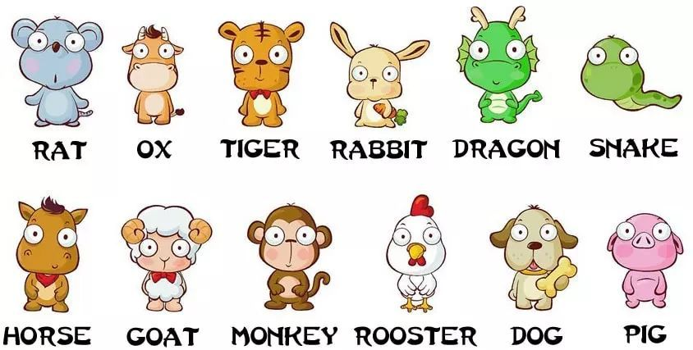



1. 日 & 月（Sun & Moon）

1. 数字 （Number）Both Pronunciation and Chinese Characters

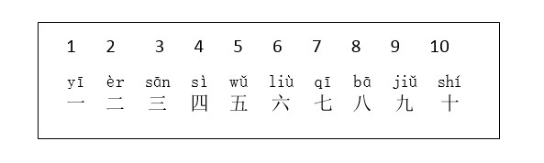

1. 书包里面有什么？ 书包里有…

1. 教室里面有什么？ 教室里有…

